# **Group Project 1 Requirements | Mobile App Prototype and Presentation** 8 Days | Groups of 3 Design Thinking Process

Your job is to research, prototype, test, and validate an idea for a brand-new mobile application. Your creation must solve a real, clearly identified need in users’ everyday lives.

Previously in this boot camp, you’ve practiced design thinking skills within the constraints of a travel application. In this independent project, you will combine *all* the skills you have learned to develop an application of your choosing.

*Note: This project will be the second case study in your UX portfolio (after your travel app prototype) and will help illustrate your mastery of UX design processes and tools.*

You will apply the design thinking process:

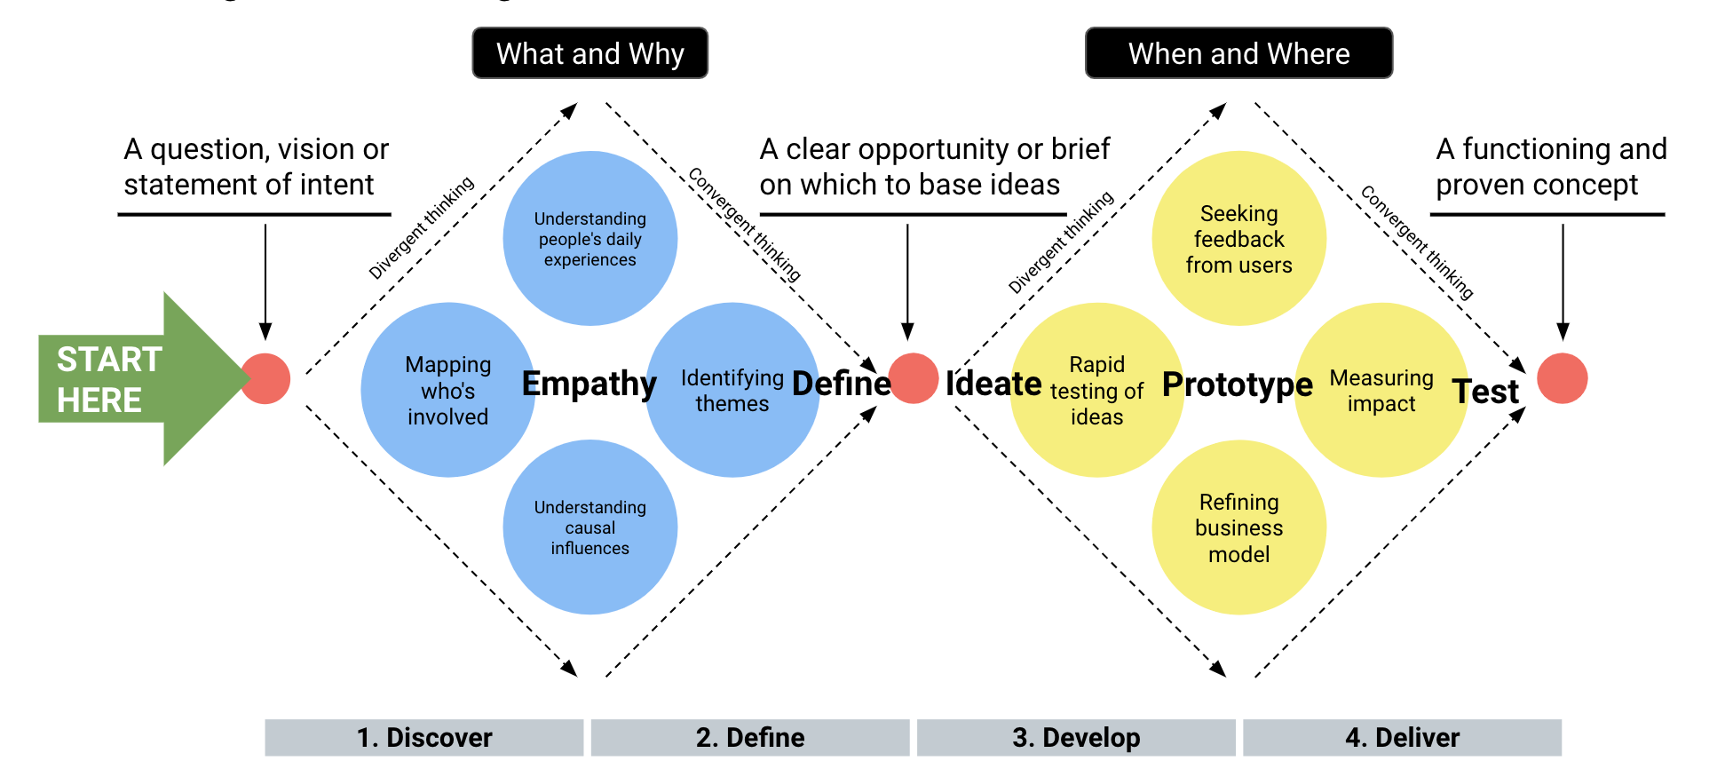

# **Project Requirements**

Work as a team to complete your project and follow the entire design thinking process. As your work progresses, update your instructor and teaching assistants (TAs).

## **Project Setup**

* **Create a Google Drive:** Share a group folder in Google Drive with your team and add your instructor and TAs.
* **Create a team Trello board:** Three weeks pass quickly; add project tasks to your Trello board and distribute among your team members to keep everyone on schedule.

**Week 1: Research > Design Thinking > Problem Definition > Ideation > Early Prototyping**

## **Day 1: Team Building, User Research, and Project Proposal**

***Your team should complete the following by next class:***

* Form your groups.
* Pitch your ideas.
* Make sure each team member can access your [Trello](https://trello.com) board.
* Create a proto-persona.
* Draft a user research plan.
* Draft an interview plan and discussion guide.
* Define a hypothesis statement.
* Set up a survey using Instagram, Facebook, Twitter, or Google Forms.
* Get feedback on your interview plan from at least one instructor or TA.
* Submit a project proposal.
  + - *Location:* Group Project 1 Proposal (Google Doc) is located in the Unit 5 Activities folder.

## **Day 2: Empathy & User Research**

***Your team should complete the following by next class:***

* Conduct five user interviews.
* Complete four interview transcripts.
* Analyze data by creating one affinity diagram.
* Synthesize data into a user persona *or* empathy map.
* Get feedback on your persona or empathy map from at least one other group.
* Define one user insight.

**Week 2: Paper Prototyping > Testing > Low-Fidelity Prototype Iteration > Testing**

## **Day 3: Definition and Ideation**

***Your team should complete the following by next class:***

* Write a defined problem statement.
* Get feedback on your problem statement from at least one other group.
* Conduct a competitor analysis.
  + Must have a minimum of four competitors.
  + Use the competitor analysis template or the strength, weakness, opportunity, and threat (SWOT) analysis template.
* Ideate or brainstorm using the mind map or the “I wish, I like, what if” method.
* Synthesize your ideas down to one to three key features using a feature prioritization matrix.
* Get feedback on your feature matrix from at least one instructor or TA.
* Create a user journey map
* Create a storyboard.
  + Get feedback on your storyboard from at least one other group.

## **Day 4: Paper Prototyping**

***Your team should complete the following by next class:***

* Complete a user flow for your team’s mobile app prototype.
* Get feedback from at least one other group on your user flow.
* Get feedback on your user flow from two different members of the instructional staff.
* Create an iterated user flow.
* Complete a clickable prototype.
  + **Note:** Each group member will individually create their own paper prototype.
    - * As a group, you will test each prototype and then collaborate on how to combine all of your key learnings into a mid-fidelity prototype.
  + Use low-fidelity sketches (i.e., paper prototypes/wireframes).
  + Display good design standards (use UI patterns, clear labels, simple colors, etc.).
  + Display good use of labels and context.
  + It must show interaction and be clickable, with no prototype dead-ends.

## **Day 5: Prototype User Testing and Iteration**

***Each of your team members should complete the following by next class:***

* Complete a user testing plan.
* Perform user tests on prototypes (tested by each group member).
* Recorded user tests via mobile device
  + - Three to five user tests
    - *Recommendation Note:* Five user tests are needed to determine most usability issues.
* Analyze the user testing data by using either:
  + Usability test analysis template
  + Guerrilla test analysis
* Make a list of recommendations for iterating the prototype.
* Agree on the most effective design solutions per analysis user tests.

**Week 3: Case Study Production and Presentation Prep > Presentations**

* **Day 6: Prototyping and Testing**

***Each of your team members should complete the following by next class:***

* Iterate user flows based on the feedback from user testing.
* Iterate wireframes based on the feedback from user testing.
* Create a rebuild of your prototype.
* Conduct usability tests on your low-fidelity prototype.

***BONUS:*** Implement the iOS or Android Material Design Guidelines:

* Show interaction and clickability with no prototype dead-ends.
* Show without color (grayscale):
  + iOS/Android resources:
    - [Android Guidelines](https://developer.android.com/design/)
      * [Material UI Design Kit](https://materialdesignkit.com/android-gui/)
    - [iOS Guidelines](https://developer.apple.com/design/human-interface-guidelines/ios/overview/themes/)
      * [iOS UI Kit](https://developer.apple.com/design/resources/)

## **Day 7: Presentation Prep**

***Your team must complete the following by next class:***

* Complete case study outline: UX Case Study Outline Template (found in activities folder).
* Rehearse your group presentation.

## **Day 8: Presentations and Critique**

On Day 8, your group will give a 10-minute presentation of your work to the class, instructors, and teaching assistants. There will be a five-minute critique and feedback session from your fellow students and the instructional team. You will have time to revise your final presentation to incorporate feedback before inclusion in your portfolio.

# **Presentation Requirements**

Presentations will take place over two days so that each team has time to share their work.

## **Group Presentation**

***Each team is responsible for the following deliverables:***

* **A presentation plan:** Include a presentation outline document with presentation responsibilities and a 10-minute timeline.
* **10-minute presentation:** Include a Google Slides document with presentation materials for your group. Your presentation should include:
  + Overall concept
  + Motivation of your user
  + User insight and problem being solved
  + Your team’s design process (Research > Design > Iterations > Tests)
  + Walkthrough of your clickable prototype
  + Future opportunities/next steps

## **Presentation Notes**

* This is a formal presentation—prepare and give it your best.
* Dress appropriately and represent your group professionally.
* Your presentation will be recorded.
* Each team member should present the aspects of the UX project that they had a unique impact on.
* While rehearsing with your group, practice talking thoughtfully and clearly about UX/UI design, prototyping, and human-centered design.
* Practice! Practice! Practice!

**Presentation Samples**

## [Microvolunteering App](https://docs.google.com/presentation/d/1Lg7PAWeXu-MR9Cf2VdybdMK64xxMfTUDFSgst_h-K48/edit#slide=id.g50e510ee88_0_356)

### [Public Restroom Finding App](https://projects.invisionapp.com/boards/6H3KF4E97UZ/)

### [Transit-Time Identification App](https://drive.google.com/open?id=1G0Pe_8B-6yOZUgdHKQB5TAkF5wOLCT_1QK-Kpq4grcg)

**Supplemental Information**

At this point in the course, you have already learned a wide variety of different techniques that UX researchers and designers use to:

* Brainstorm and ideate in an organized and structured fashion.
* Perform exploratory user research through interviews and surveys.
* Identify and prioritize user needs.
* Create core UX process deliverables, such as user insights, user flows, personas, problem statements, wireframes, and prototypes.
* Research and create SWOT and competitor analyses to understand the landscape.
* Create clickable prototypes with professional wireframing tools.
* Perform rapid usability or guerrilla testing.
* Create UX case study documentation to aggregate and communicate designs.
* Converge and present a well-researched idea.

*Note:* If you don’t remember some of these techniques, review previous activities and templates in your class Google Drive. You can also use Google to research other resources.

**Grading**

You will receive a letter grade based on how well you execute the requirements above. The breakdown will be as follows:

* Project Design Process: 50%
* Prototype: 25%
* Presentation: 20%
* Collaboration/Teamwork: 5%

More importantly, your instructional staff will be providing feedback on the overall project: process, teamwork, presentation, and prototypes.